SMART EMBEDDED SYSTEM FOR POTHOLE DETECTION

**Internship Project Report**

*Submitted*

**by**

**NSMP Phani kiran,21ECB0B36**

**MVS Srimanth,21ECB0B33**

**K Ajay kumar,21ECB0B28**

**T VEERA KUMAR,21ECB0B62**

**T VEERA GANESH,21MEB0A64**



Under the guidance of

**Prof P. Muralidhar**

Associate professor,

**DEPARTMENT OF ELECTRONICS AND COMMUNICATION ENGINEERING**

**NATIONAL INSTITUTE OF TECHNOLOGY, WARANGAL**

**June 2024**

NATIONAL INSTITUTE OF TECHNOLOGY

# WARANGAL - 506 004

**CERTIFICATE**

**This is to certify that ,of NIT Warangal have successfully completed a Project titled “**SMART EMBEDDED SYSTEM FOR POTHOLE DETECTION**”, as part of Summer Internship Programme under my guidance at National Institute of Technology, Warangal, Telangana, during 20-05-2024 to 20-07-2024.**

**Prof P.Muralidhar,**

**Assistant professor,**

**Department of ECE,**

**NIT, Warangal.**

**Proposed Title**:SMART EMBEDDED SYSTEM FOR POTHOLE DETECTION

**ABSTRACT**:

In this project, we present an advanced road safety system that revolutionizes pothole detection and management through the integration of high-resolution cameras, ultrasonic sensors, and GPS technology. This innovative system is designed to detect potholes with high precision in various weather conditions, ensuring timely and efficient road maintenance while enhancing driver safety.

The system employs strategically placed high-resolution cameras on vehicles to capture clear images of potholes. Simultaneously, ultrasonic sensors detect variations in ground clearance as the vehicle passes over potholes. This data is then tagged with GPS coordinates, providing an accurate and up-to-date map of road conditions. The captured images and locations of potholes are promptly relayed to municipal authorities, enabling timely repairs and effective prioritization of the most critical issues.

A key innovation of this system is its ability to prioritize pothole repairs, allowing municipal corporations to address the most urgent problems first. Additionally, the integration of GPS technology offers real-time alerts to drivers about upcoming potholes, ensuring safer navigation and reducing the risk of vehicle damage.

Overall, this invention significantly improves the efficiency of road maintenance operations by providing proactive guidance to drivers and minimizing the risk of accidents caused by poor road conditions. By leveraging advanced sensor technology and real-time data processing, our system represents a significant leap forward in enhancing road safety and maintenance.

**Key Words:**

1. Adaptive Functionality
2. Driver Assistance Module
3. GPS Integration
4. Ground Clearance
5. High-Resolution Cameras
6. Municipal Authorities
7. Pothole Detection
8. Real-time Alerts
9. Road Safety
10. Ultrasonic Sensors

**Background of the Invention:**

The state of road infrastructure in India is a pressing issue, with numerous roads plagued by potholes, rough patches, and blocked lanes. This deteriorated condition of roads not only compromises the driving experience but also poses significant safety risks. The presence of potholes is a major concern, causing substantial damage to vehicles, injuries to drivers, and accidents that endanger both drivers and passengers. The current mechanisms in place for detecting and repairing potholes are inefficient and often slow, exacerbating the problem and leading to prolonged periods of hazardous road conditions.

Potholes and rough patches form due to various reasons such as poor road construction, inadequate maintenance, and extreme weather conditions. Over time, these issues worsen, creating dangerous driving environments that result in vehicle damage and increased maintenance costs. Furthermore, blocked lanes due to unaddressed road issues lead to traffic congestion, delays, and additional fuel consumption, impacting the overall economy and environment.

The urgency to address these challenges has driven the need for a more efficient and proactive solution. Our invention aims to revolutionize the way potholes are detected and managed, providing a comprehensive system that enhances road safety and maintenance efficiency. By integrating high-resolution cameras, ultrasonic sensors, and GPS technology, our solution ensures precise detection of potholes and real-time communication with municipal authorities for timely repairs.

This innovative system not only identifies and prioritizes the most critical potholes but also offers real-time alerts to drivers, helping them navigate safely and avoid potential accidents. By addressing the root causes of road degradation and implementing a proactive maintenance strategy, our invention seeks to significantly improve the overall condition of roads in India, making them safer and more reliable for all users.

In summary, the current state of roads in India demands an urgent and effective solution. Our invention provides a robust response to these challenges, offering a technological approach that enhances road safety, reduces vehicle damage, and ensures efficient road maintenance. Through this advanced system, we aim to create a safer and more pleasant driving experience for everyone.

**INTRODUCTION:**

The state of road infrastructure in India is a pressing concern, with numerous potholes, rough patches, and blocked lanes making driving not only uncomfortable but also hazardous. These road conditions lead to significant vehicle damage, injuries, and accidents, posing a substantial threat to drivers and passengers alike. Current methods for pothole detection and repair are inefficient, failing to address the problem promptly and effectively.

To tackle these issues, we have developed a revolutionary system that integrates high-resolution cameras, ultrasonic sensors, and GPS technology to detect and manage potholes with high precision, regardless of weather conditions. This innovative system captures the locations and images of potholes, promptly notifying municipal authorities for timely repairs. Additionally, it provides real-time alerts to drivers about upcoming potholes, ensuring safer navigation and reducing potential damage to vehicles.

Our system's ability to prioritize pothole repairs allows municipal corporations to address the most critical issues first, thereby optimizing resource allocation and maintenance efforts. The strategic placement of high-resolution cameras ensures clear images of potholes, while ultrasonic sensors detect ground clearance variations as vehicles pass over them. This data, tagged with GPS coordinates, creates an accurate and up-to-date map of road conditions.

This invention significantly enhances road maintenance efficiency and driver safety by providing proactive guidance and minimizing the risk of accidents due to poor road conditions. By leveraging advanced sensor technology and real-time data processing, our system represents a substantial leap forward in enhancing road safety and maintenance.

**DESCRIPTION OF COMPONENTS:  
High-Resolution Cameras**

The high-resolution cameras used in the system are connected to the Raspberry Pi 3B+ via its camera interface. These cameras, such as the Raspberry Pi Camera Module V2, provide 8 megapixels of resolution and can capture images at 720p. They are strategically mounted on the vehicle to capture continuous images of the road surface, enabling real-time monitoring and detection of potholes. The captured images are processed by the Raspberry Pi to identify potential potholes.

### Ultrasonic Sensors

Ultrasonic sensors, like the HC-SR04, are employed to measure the distance between the vehicle and the road surface, detecting variations indicative of potholes. These sensors are connected to the Raspberry Pi 3B+ via GPIO pins. The Raspberry Pi uses these readings to confirm the presence and depth of potholes. The sensors operate within a range of 2cm to 400cm and provide accurate measurements essential for pothole detection, especially in conditions where camera visibility is compromised.

### GPS Module

A GPS module, such as the NEO-6M, is integrated into the system to record the precise locations of detected potholes. This module connects to the Raspberry Pi via UART or USB and provides real-time location data with an accuracy of 2.5 meters. The GPS data is essential for mapping road conditions and notifying municipal authorities of the exact locations of potholes, ensuring timely repairs.

### Raspberry Pi 3B+ as the Central Processing Unit

The Raspberry Pi 3B+ serves as the central processing unit for the system. It is responsible for collecting data from the high-resolution cameras, ultrasonic sensors, and GPS module. With a 1.4GHz 64-bit quad-core processor and 1GB of RAM, the Raspberry Pi 3B+ processes the image data using machine learning algorithms to detect potholes. It also handles the real-time communication of detected pothole locations to municipal authorities and provides navigation alerts to drivers

**Working:**

The system integrates multiple sensors, cameras, and a central processing unit to ensure accurate and efficient identification of potholes. Here is a detailed explanation of how each component works together to achieve this:

**Ultrasonic Sensors**

The system utilizes five ultrasonic sensors to detect potholes based on torsional stress and variations in ground clearance:

1.**Sensors at Four Wheels**: Each wheel of the vehicle is equipped with an ultrasonic sensor (e.g., HC-SR04), which measures the distance between the vehicle and the road surface. These sensors detect changes in ground clearance as the vehicle passes over a pothole, based on the principle of torsional stress. When a wheel encounters a pothole, the sudden drop in clearance is registered by the sensor.

2. **Central Sensor:** An additional ultrasonic sensor is placed at the center of the vehicle. This sensor measures the overall ground clearance and detects any significant increases in value, which can indicate the presence of a pothole.

These sensors are connected to the Raspberry Pi 3B+ via GPIO pins. The readings from all five sensors are continuously monitored and analyzed by the Raspberry Pi to identify potential potholes.

**High-Resolution Cameras:**

The system includes high-resolution cameras (such as the Raspberry Pi Camera Module V2) strategically mounted on the vehicle to capture live video feeds of the road surface. The video feed is converted into frames, which are then processed by a machine learning (ML) algorithm running on the Raspberry Pi. The ML algorithm is trained to identify potholes based on patterns and features in the images. Each frame is analyzed to detect the presence of potholes.

**Dual Validation Process:**

For a pothole to be confirmed, both the ultrasonic sensors and the cameras must identify it. The dual validation process involves:

1. Sensor Data: When the ultrasonic sensors detect a sudden change in ground clearance, the data is flagged as a potential pothole.

2. Image Analysis: Simultaneously, the ML algorithm processes the camera frames. If the algorithm identifies a pothole in the corresponding frame, the potential pothole flagged by the sensors is confirmed.

This dual validation ensures high accuracy in pothole detection, reducing false positives.

**GPS Module**

Once a pothole is detected and confirmed, the system uses a GPS module (such as the NEO-6M) connected to the Raspberry Pi via UART or USB to record the precise location of the pothole. The GPS data provides real-time location information with an accuracy of 2.5 meters. This information is critical for mapping the exact location of potholes.

**Data Storage and Dashboard Representation**

The detected pothole locations, along with their GPS coordinates, are inserted into a MySQL database. The database stores all the pothole data, which is used to represent the intensity and distribution of potholes in different regions on a dashboard. The dashboard provides a visual representation of:

1. Pothole Density: The number of potholes in specific regions.

2. Traffic Impact: The number of vehicles passing over each pothole.

This information helps municipal authorities prioritize repair efforts based on the severity and impact of potholes.

**Dashboard Features**

The dashboard offers several key features:

1. Pothole Intensity Map: Displays the density of potholes in different regions, highlighting areas with high concentrations.

2. Traffic Analysis: Shows the number of vehicles that encounter each pothole, indicating the impact on traffic flow and road safety.

3. Repair Management: Includes a delete option that allows users to remove pothole locations from the database once they have been repaired. This feature ensures that the dashboard remains up-to-date and accurately reflects the current state of the roads.

**System Integration and Adaptation**

The Raspberry Pi 3B+ serves as the central processing unit, integrating all components and managing their interactions. It processes data from the ultrasonic sensors, cameras, and GPS module in real-time, ensuring immediate analysis and response. The system is designed to adapt to various weather conditions, switching between camera-based and sensor-based detection as needed. For instance, in foggy or rainy conditions where camera visibility is compromised, the system relies more on ultrasonic sensors for detection.

Overall, the comprehensive system leverages high-resolution imaging, precise sensor measurements, accurate location tracking, and advanced data processing to address the challenges of pothole detection and road maintenance efficiently. This integrated approach ensures enhanced road safety, timely repairs, and improved driving experiences.

**FLOWCHARTS AND BLOCK DIAGRAMS:**

**Detection of Pothole:**

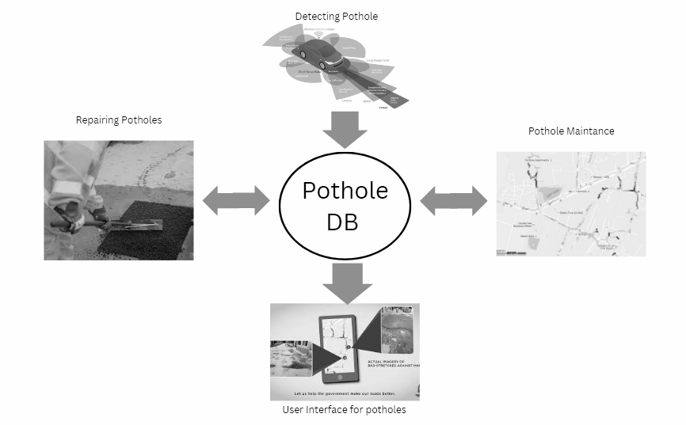

**Block Diagrams**

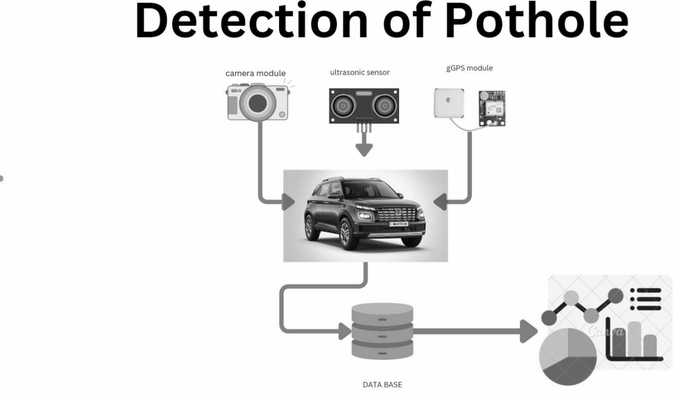

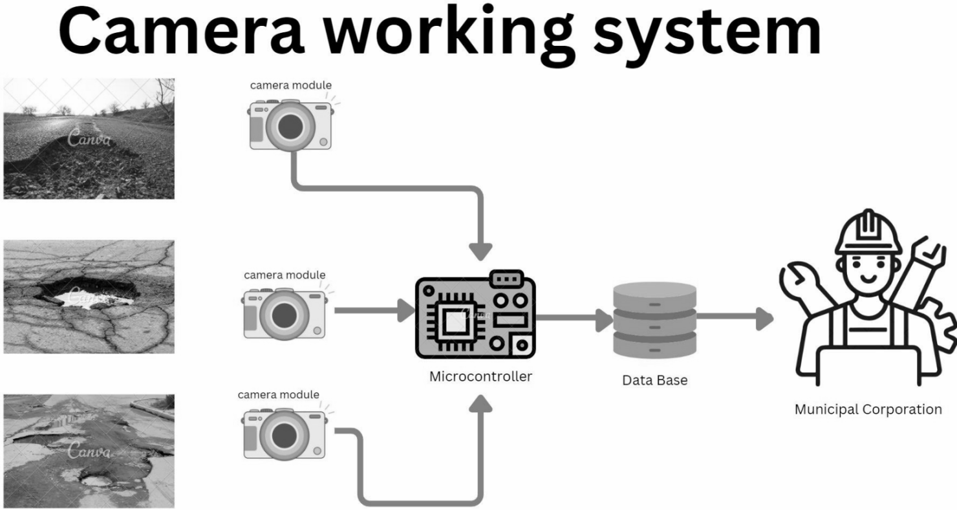

**Flowchart of camera working:  
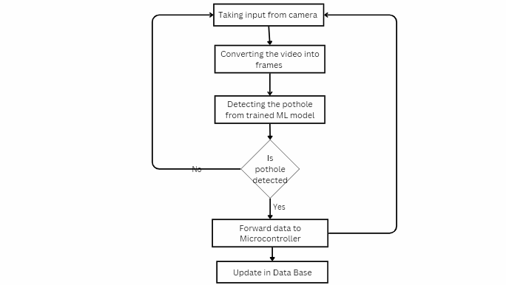**

**Flowchart of Ultrasonic Sensor:**

**i) Sensor at centre of car**

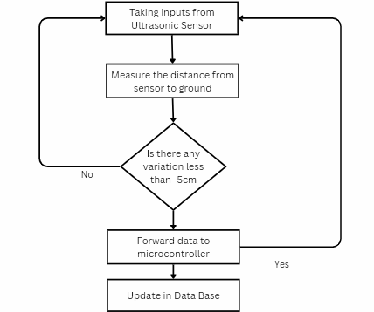

**ii) Sensor near tyres**

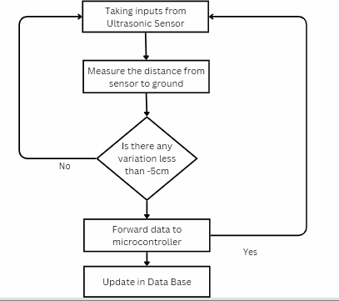

**Ultrasonic Sensor working system:**

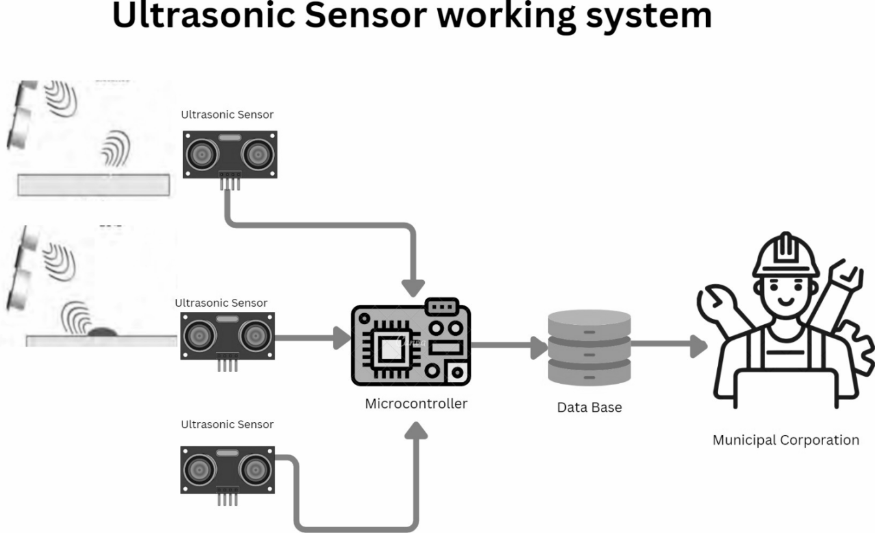

**Flowchart of GPS Module:**

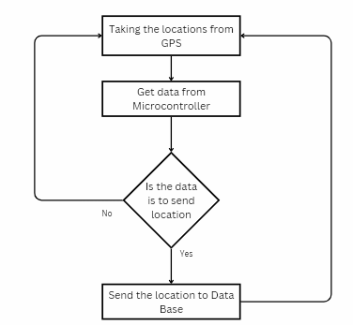

**GPS Module working system**

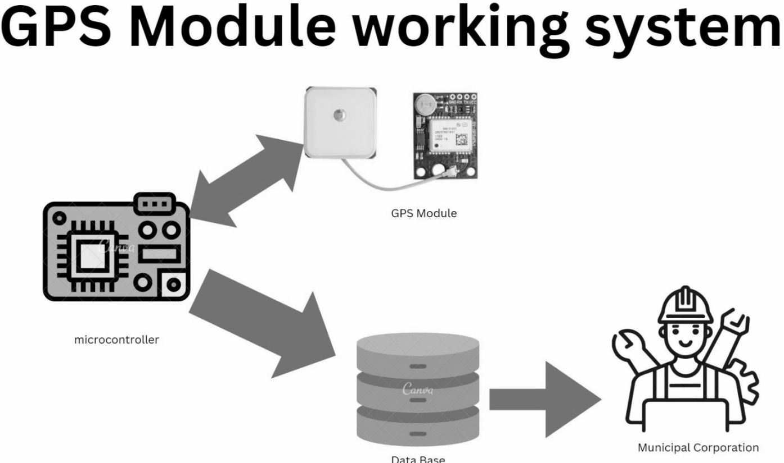

**Flowchart of Microcontroller:**

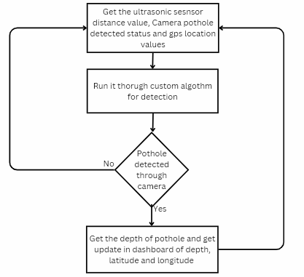

**Flowchart for updating Dashboard:**

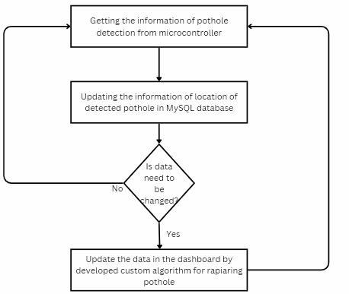

**Overall Architecture:**

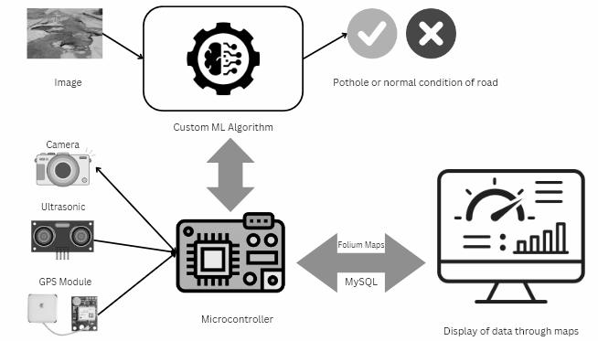

**Workable ranges:**

1. **Camera Resolution:** 720p to 4K resolution.
2. **Ultrasonic Sensor Range:**  5 cm to 4 meters.
3. **GPS Accuracy:** Within 1 to 3 meters.
4. **Data Processing Speed:** Real-time processing within milliseconds to a few seconds.(20ms)
5. **Environmental Conditions:** Operational from 4°C to 50°C and in various weather conditions including rain, fog, and snow.

Results:

output in the terminal if the pothole is detected:

our prototype with hardware: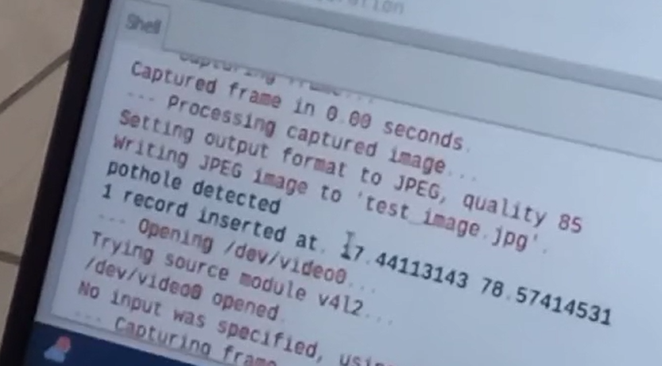

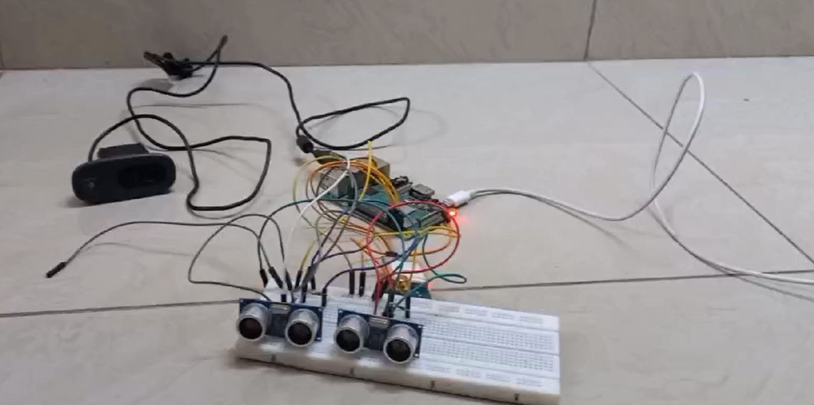

pothole detected updated in the web app:

**Future Scope:**

**The current pothole detection system is robust, but there are several opportunities to enhance its capabilities and expand its applications in the future:**

**1. Advanced Sensor Integration**

**- Lidar Sensors: Integrating Lidar sensors could provide even more precise distance measurements and enhance the detection of potholes and other road anomalies.**

**- Inertial Measurement Units (IMUs): Adding IMUs could improve the accuracy of pothole detection by capturing the vehicle’s pitch, roll, and yaw, which can be correlated with pothole impacts.**

**2. Enhanced Machine Learning Models**

**- Deep Learning: Implementing more advanced deep learning techniques, such as convolutional neural networks (CNNs), could improve the accuracy and reliability of pothole detection from camera images.**

**- Real-time Model Training: Incorporating mechanisms for continuous learning and model updates based on new data could keep the system adaptive to various road conditions and pothole types.**

**3. Expanded Data Analytics**

**- Predictive Maintenance: Utilizing historical data to predict potential pothole locations and road conditions could help in proactive maintenance and resource allocation.**

**- Big Data Integration: Combining data from multiple sources, such as traffic patterns and weather conditions, could provide a more comprehensive analysis of road conditions and prioritize repairs more effectively.**

**4. Enhanced Communication Systems**

**- Vehicle-to-Everything (V2X) Communication: Integrating V2X technology could enable vehicles to share pothole information with each other and with infrastructure, improving overall road safety and traffic management.**

**- Real-time Notifications: Developing mobile applications that provide real-time pothole alerts and navigation recommendations to drivers could further enhance driver safety and route planning.**

**5. Scalability and Deployment**

**- Fleet Expansion: Extending the system to a fleet of vehicles, such as buses and delivery trucks, could provide more extensive coverage and data collection, leading to a more accurate map of road conditions.**

**- Integration with Municipal Systems: Collaborating with municipal authorities to integrate the pothole data directly into their road maintenance systems could streamline the repair process and resource management.**

**6. Environmental Adaptation**

**- Weather Resilience: Improving the system’s performance in adverse weather conditions (e.g., heavy rain, snow) by using additional sensors or enhancing image processing algorithms could ensure reliable detection year-round.**

**- Seasonal Adjustments: Implementing seasonal adjustments to account for variations in road conditions due to temperature changes, such as freeze-thaw cycles, could enhance detection accuracy.**

**7. User Experience and Accessibility**

**- Enhanced Dashboard Features: Adding features like interactive maps, historical trend analysis, and user feedback mechanisms could improve the usability and functionality of the dashboard for municipal authorities and road maintenance teams.**

**- Public Awareness: Developing public-facing tools or apps to inform drivers about road conditions and pothole locations could help reduce accidents and vehicle damage.**

**By exploring these future scopes, the pothole detection system can evolve to provide even more accurate, efficient, and user-friendly solutions for road maintenance and safety.**

**REFERENCES**:

1. **IEEE Xplore Digital Library** - Example Reference: "2019 IEEE 16th India Council International Conference (INDICON)."
2. **DOI (Digital Object Identifier) Systems** - Example Reference: Bhoyar, D., Khobragade, R. H., Mohod, S. K., & Fulzele, P. (2023). "IoT Based Pothole Detection and Alert System." 2023 1st DMIHER International Conference on Artificial Intelligence in Education and Industry 4.0 IDICAIEI 2023. <https://doi.org/10.1109/IDICAIEI58380.2023.10406520>
3. **Journal of Emerging Trends in Computing and Information Sciences** - Example Reference: Kim, T., & Ryu, S.-K. (2014). "Review and Analysis of Pothole Detection Methods." 5(8). <http://www.cisjournal.org>
4. **Applied Sciences (Switzerland)** - Example Reference: Kim, Y. M., Kim, Y. G., Son, S. Y., Lim, S. Y., Choi, B. Y., & Choi, D. H. (2022). "Review of Recent Automated Pothole-Detection Methods." In Applied Sciences (Switzerland) (Vol. 12, Issue 11). MDPI. <https://doi.org/10.3390/app12115320>
5. **Institutional Repositories** - Example Reference: McGill, A. L., Simmons, B. G., Querry, S. D., & Hammell, E. J. (2016). "Pothole Reporting System." <http://ideaexchange.uakron.edu/honors_research_projects/242>
6. **International Journal of Advanced Research in Biology Engineering Science and Technology (IJARBEST)** - Example Reference: Mohanaprakash, K., Brindha, S., Gowri, S., & Lathamaheswari, K. (2016). "Implementation of Vehicle Speed Limiting and Pothole Identification Using Ultrasonic Sensor."
7. **Proceedings from IEEE International Conferences** - Example Reference: Sb, S., Km, A. B., & Mishra, G. (2021). "Sensor Based Pothole Detection System." Proceedings - 2021 IEEE International Conference on Cloud Computing in Emerging Markets CCEM 2021, 15–22. <https://doi.org/10.1109/CCEM53267.2021.00013>
8. *2019 IEEE 16th India Council International Conference (INDICON).* (n.d.). IEEE.
9. Bhoyar, D., Khobragade, R. H., Mohod, S. K., & Fulzele, P. (2023). IoT Based Pothole Detection and Alert System. *2023 1st DMIHER International Conference on Artificial Intelligence in Education and Industry 4.0, IDICAIEI 2023*. <https://doi.org/10.1109/IDICAIEI58380.2023.10406520>
10. Kim, T., & Ryu, S.-K. (2014). *Journal of Emerging Trends in Computing and Information Sciences Review and Analysis of Pothole Detection Methods*. *5*(8). <http://www.cisjournal.org>
11. Kim, Y. M., Kim, Y. G., Son, S. Y., Lim, S. Y., Choi, B. Y., & Choi, D. H. (2022). Review of Recent Automated Pothole-Detection Methods. In *Applied Sciences (Switzerland)* (Vol. 12, Issue 11). MDPI. <https://doi.org/10.3390/app12115320>
12. McGill, A. L., Simmons, B. G., Querry, S. D., & Hammell, E. J. (2016). *Pothole Reporting System*. <http://ideaexchange.uakron.edu/honors_research_projectshttp://ideaexchange.uakron.edu/honors_research_projects/242>
13. Mohanaprakash, K., Brindha, S., Gowri, S., & Lathamaheswari, K. (2016). IMPLEMENTATION OF VECHILE SPEED LIMITING AND POTHOLE IDENTIFICATION USING ULTRASONIC SENSOR. In *Online) International Journal of Advanced Research in Biology Engineering Science and Technology (IJARBEST)* (Vol. 2, Issue 10).
14. Saveetha Engineering College. Department of Electronics and Communication Engineering, Saveetha Engineering College. IEEE Student Branch, Institution of Electronics and Telecommunication Engineers (India), & Institute of Electrical and Electronics Engineers. (n.d.). *7th International Conference on “Smart Structures and Systems” : 23rd & 24th July, 2020*.
15. Sb, S., Km, A. B., & Mishra, G. (2021). Sensor Based Pothole Detection System. *Proceedings - 2021 IEEE International Conference on Cloud Computing in Emerging Markets, CCEM 2021*, 15–22. <https://doi.org/10.1109/CCEM53267.2021.00013>